Stroke Prediction

# **Vinay Nagaraj DSC680 - T302 Applied Data Science (2217-1) https://vinaynagaraj88.github.io/DataScience_Portfolio/**

# 10 Questions & Answers

1. What's the % of Stroke Patients in our dataset? – 4.87%. Out of 5110 records, 249 of them are data related to patients who had stroke.

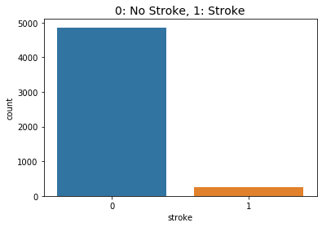

1. How does Smoking effect Stroke? – Being a smoker or a formerly smoker increases your risk of having a stroke. Also, looks like people who used to smoke are more prone to a Stroke than people still smoking.

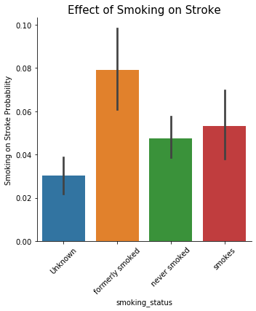

1. Effects of marriage on Stroke? – Chances of stroke are more if you are married.

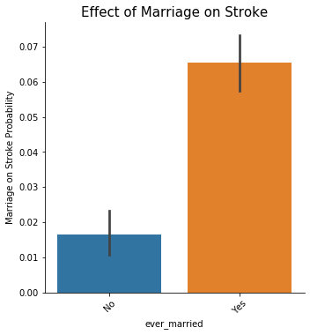

1. Does heart disease increase your chances of Stroke? – Yes, People with a history of heart disease are more prone to Stroke.

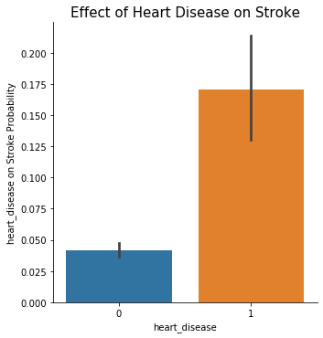

1. Does HyperTension increase your chances of Stroke? – Yes, People with a history of Hypertension are more prone to Stroke.

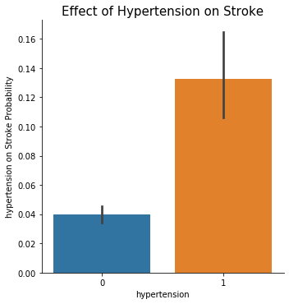

1. Effect of Gender on Stroke? - Male are more prone to Stroke when compared to Females.

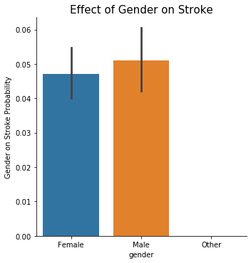

1. Stroke distribution by Age? - Age is a big factor in stroke patients - the older you get the more at risk you are.

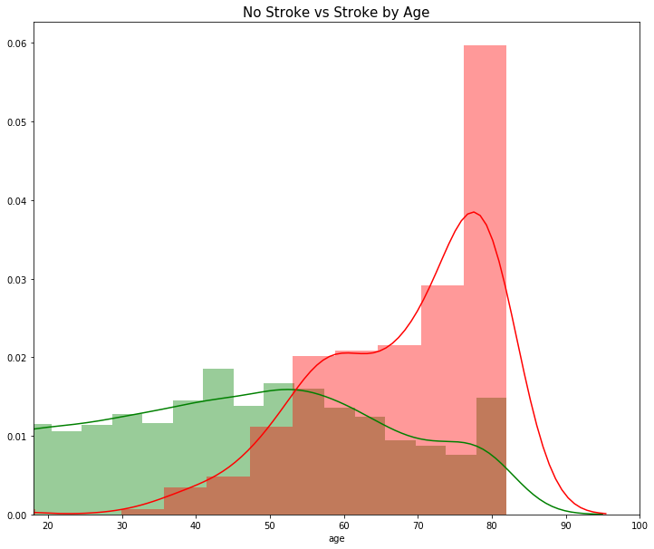

1. Effect of Work Type on Stroke? – Private work type exposes you to more stroke, than being self-employed or Govt work.

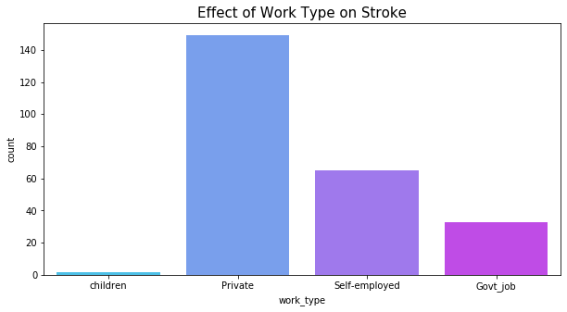

1. Which are the important features which can predict employee attrition? – ‘Age’ is the most important feature per SelectKBest technique.

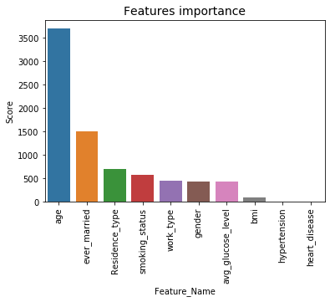

1. Which are the best suited classification models to predict employee attrition? - Random forest model has fewer false positives than other models making it a better model and will correctly predict if the Patient might have a stroke or not 88.71% of the time.